Design & Development of Olive pitting and Grading Machine

Supervisors :

Dr. Umar Shahbaz Khan
Mechatronics Engineering
NUST College of Electrical and Mechanical Engineering
Islamabad, Pakistan
u.shahbaz@ceme.nust.edu.pk

Student :
Ahmed Waqar Rao
Mechatronics Engineering
NUST College of Electrical and Mechanical Engineering
Islamabad, Pakistan ahmedwaqarrao.909@gmail.com

Dr. Hamid Jabbar
Mechatronics Engineering
NUST College of Electrical and Mechanical Engineering
Islamabad, Pakistan
hamid.jabbar@ceme.nust.edu.pk

Dr. Ameer Hamza
Mechatronics Engineering
NUST College of Electrical and Mechanical Engineering
Islamabad, Pakistan
a.hamza@ceme.nust.edu.pk

Abstract— the invention in the technological world in Olive processing industry which increases the demand of the Olive industry. Olive pitting machine is mainly used for crushing and pitting of olives. The destoning of olive is the major area of concern in this project. A prototype is designed known as semi-autonomous machine for the extraction of olive and pitting process. Our Project is mainly focus on the Design of the Olive pitting Machine & Grading Machine.
This machine will operate on no of mechanisms such as Geneva and slider crank mechanism. The assembly of machine is designed keeping in mind that all sizes of olives can be placed in one go on which pitting process need to be carried out. The major concern of our project lies in passing olives through fruit grading machine and then after this put that passed Olive into the Olive Pitting Machine whose task is to remove the seeds or pits of olives successfully the without damaging the outer part of the fruit.
The project we have chosen for our FYP has both commercial and industrial value. The project holds to remove pit from olives mesh and then these olives can serve application in foods we are used on daily basis like tables olives, pickled olives and for extracting olives oil. Our area of target is to design a prototype whose specifications is grading olive one their sizes and destoning of pits.

- Introduction
Olive industry is growing day by day with the in interventions of technological solutions in olives process industry. The project holds to remove pit from olives mesh and then these olives can serve application in foods like tables olives and oil can also be extracted from the oils and is also used in pickels. We are to design a semi-automated machine whose function is to remove pit form olives [1].
There are 3 major parts in this semi-automated machine i.e., Olive feeder, Olive carrier, Pit detaching device. Olive feeder is the only semi-automatic part of the machine. In olive feeder olives need to be placed in such a way that it is in perfect contact with tip of needle and needle strike them longitudinally.

Olive carrier is a revolving drum with sockets to hold various sizes of olives in predetermined position. The 24V motor is needed to rotate this drum and when needle encounter olive means when it strikes the olive then drum stop rotating. Pit detaching device consists of system of 9 needles which is capable of destoning 9 olives in just one go. The invention in the technological world in Olive processing industry which increases the demand of the Olive industry [3].

Olive pitting machine is mainly used for crushing and pitting of olives [2]. Our Project is mainly focus on the Design of the Olive pitting Machine & Grading Machine. The major objective of the of this project first to pass the olive through the Grading Machine and then after this put that passed Olive into the Olive Pitting Machine which successfully remove the pit of the olives without fracturing the outer part of the fruit [4]. The pitted Olive fruit can give us the income generating tool by making olive table oils, pickled olive and sliced or chopped olives can be use on pizza etc.

The Selected design of the Olive Extracting Machine resembles the cherry machine with modification in the driving mechanism having a Geneva Mechanism Crank-Slider Mechanism for the head of the device with a pitting needle. Holes of Rollers are selected according to the Grade of Olives needed to be pitted after being graded by the Olive Sorting Machine.
The Pitting Machine Also includes Feeder and Collector Assembly for Feeding and collecting olives, respectively [5]. Mechanical System Based Olive Sorting: Mechanical based system for olive grading is the most used methodology. Mechanical Sorting Consists of Feeder Assembly through which olives are sent to conveyor belts arranged so that they are hollow from the bottom and carry the olives while moving forward.

- Methodology

Important paramteres and calculations

DEVELOPMENT PHASE OF PITTING & GRADING MACHINE COMPONENT SPECIFICATIONS

The overall parameters of the olive hopper, grading drums with holes; the length and diameters of drums, diameter and total number of holes and exit fall of the development grading-machine are included as follows.

FINAL 3D CADCAM MODEL
This is the final achieved 3D CAD model of olive grading mechanism, after assembling all the parts. We entered the olives in 3 stages. First, we put 5kg of olives then 10kg and in 3rd stage we put 15kg of olives in the hopper, by 220 volts motor placed on the other side of the machine, the rolling drums starts to roll.

Respective olives fall in 3 different categories according to their diameters which varies from 19mm diameter to 29mm.

After combining various mechanisms and components, the entire assembly of Olive Pit Extractor machine is obtained.
The shaft of the prime mover in the Geneva mechanism is connected to the crank in the slider crank mechanism.

The primary mover's wheel will be turned by an AC induction motor. The crank would generate rotational motion, which would be transformed into linear motion by the slider. The needle box is attached to the slider, and when linear motion is produced, the needle box moves along with the slider to conduct pitting operation.

When the shaft of the prime mover catches on the slot of the driven wheel, it rotates the roller drum 45 degrees and aligns the roller drum sockets with those of the needle box for correct olive pitting.

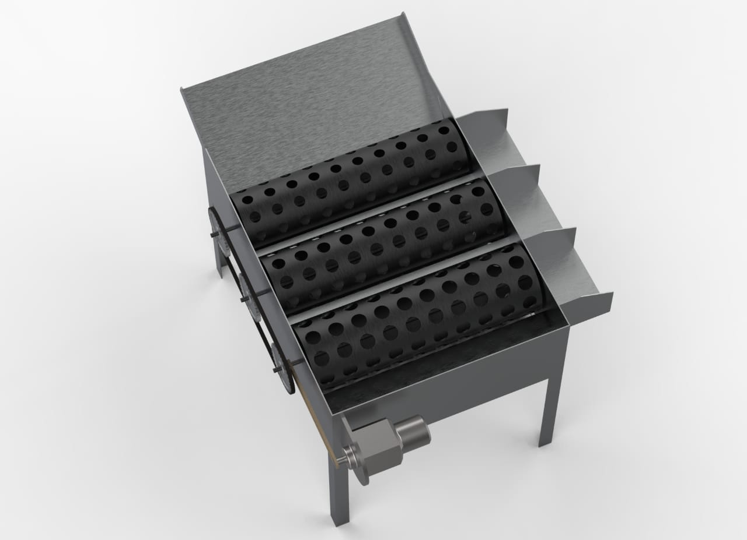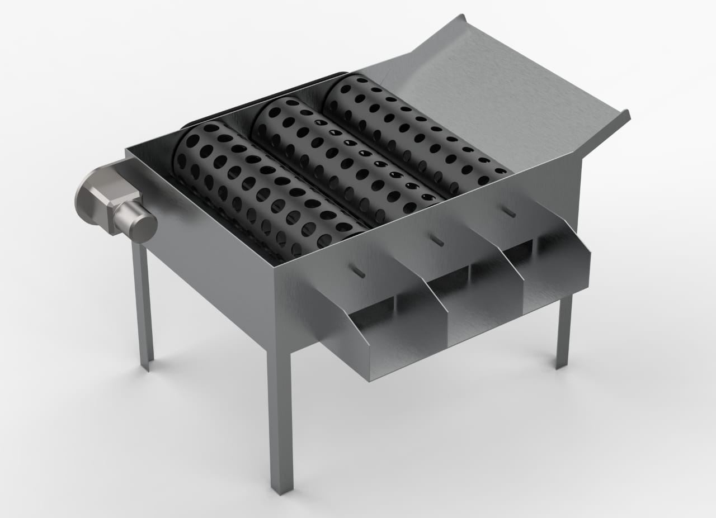
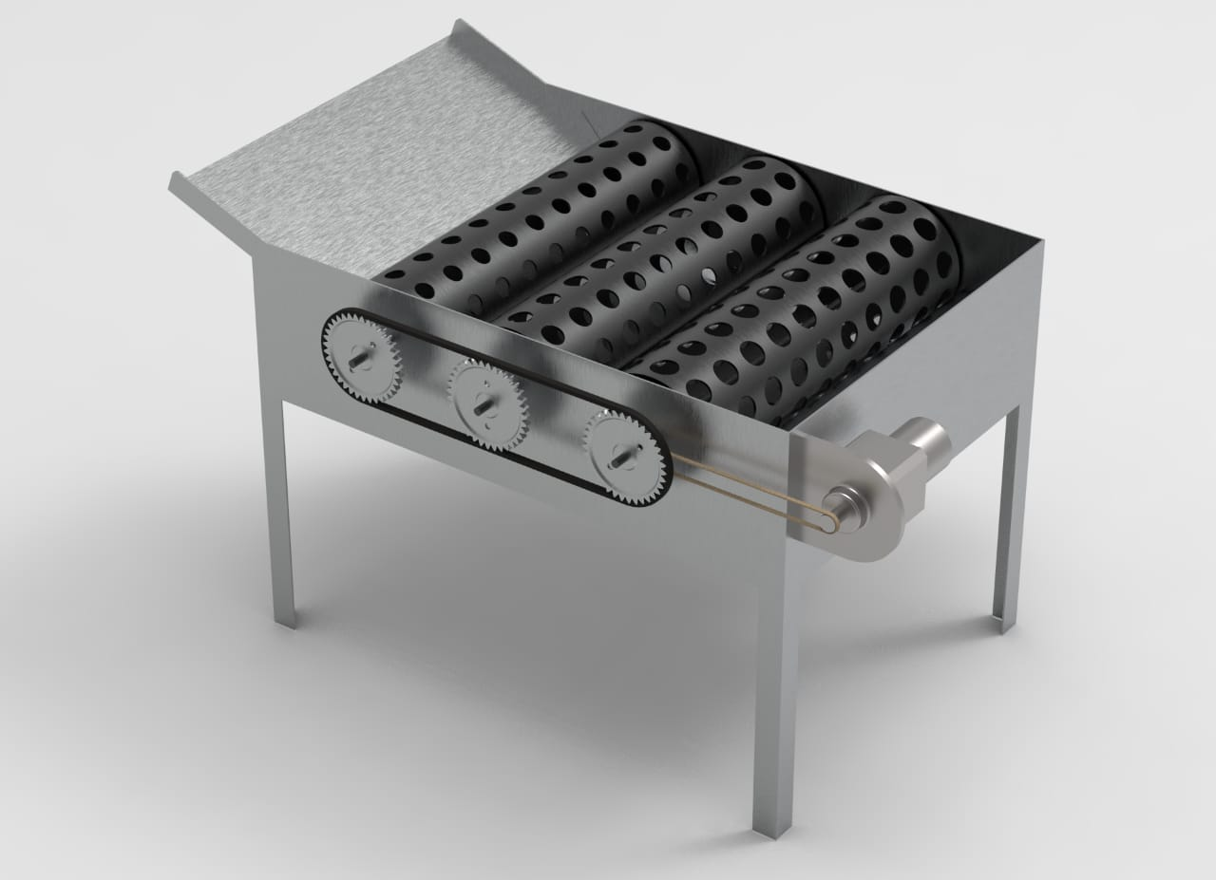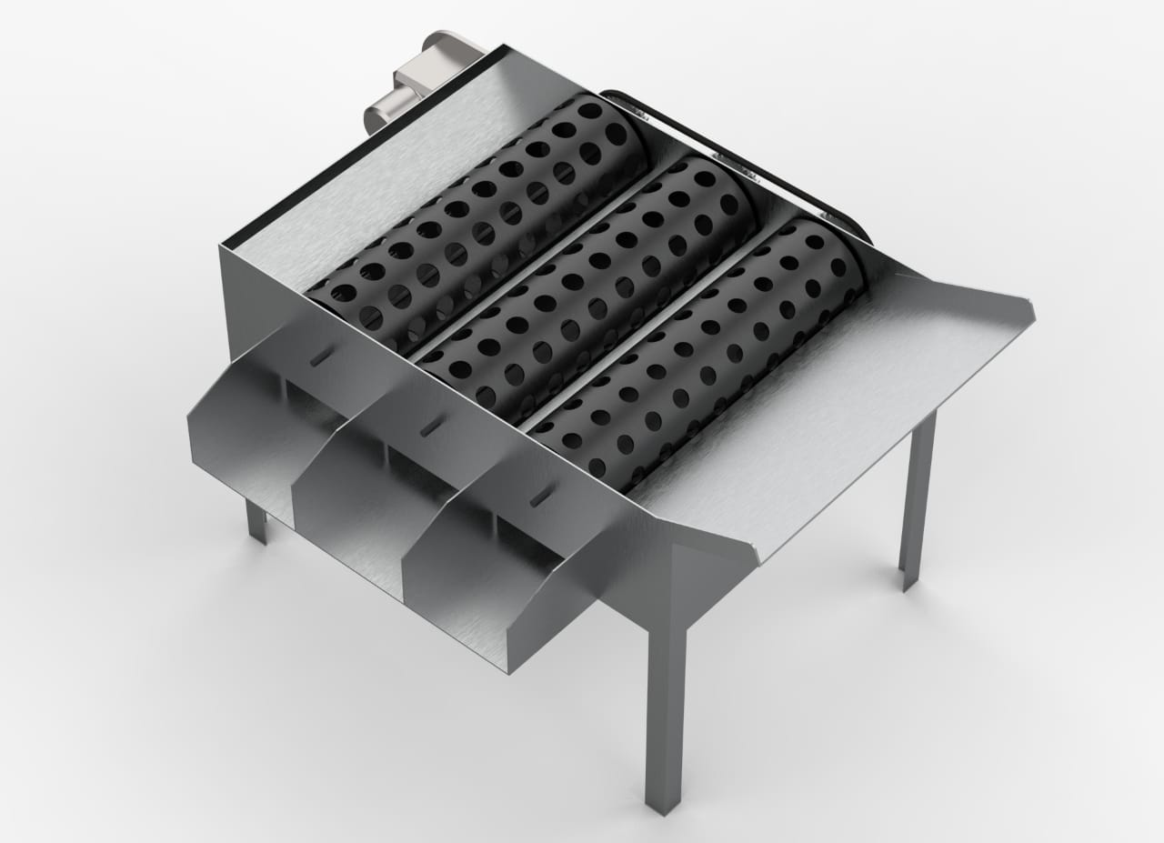

Final 3d Cad Model Of Gradig Machine
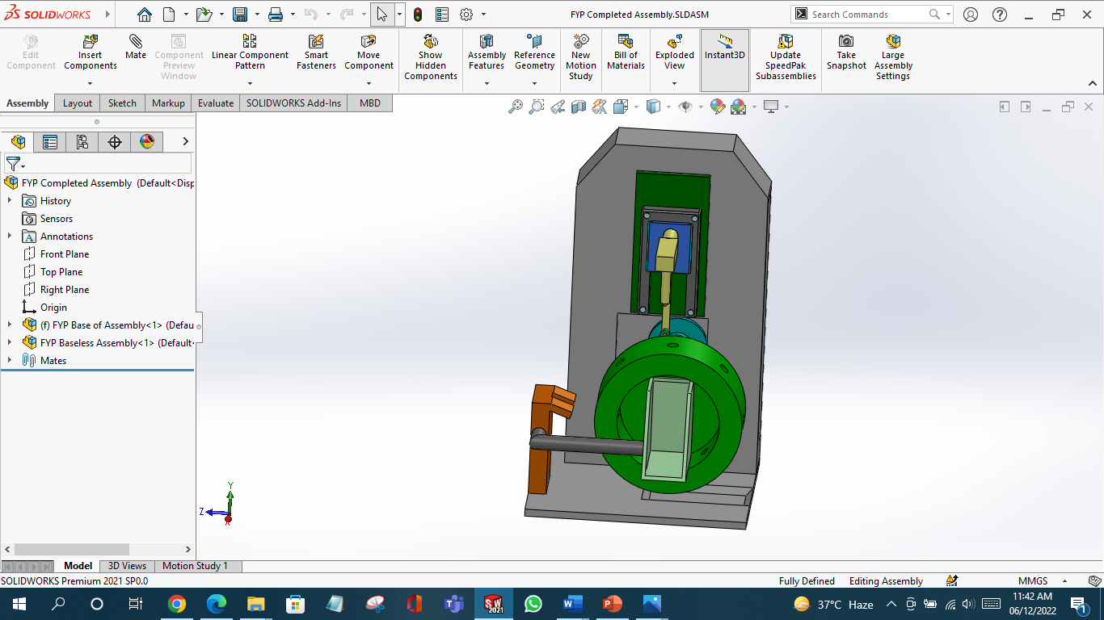

Final 3d Cad Model Of pitting Machine

C) Food Grading by Computer Vision:

In this modern era of industrialization, computer vision has become the most influential factor in revolutionizing the food industry. Food grading, including the size, orientation, Volume, weight, color, and checking the quality of a particular food type, has become very easy using computer vision. Machine Learning and Machine Vision make the perfect artificial intelligence system used for food processing. [10]

1) Working:
The most used Computer Vision Grading of Olives include grading by Size and color. Modern image processing techniques are used to distinguish the difference in color and sizes. For imaging, High-Speed Cameras are used to capture images as fast as up to 120 frame rates.

Data Acquisition Card (DAC) is used to control the system. Machine Learning is a must to process and compare the data to provide the best results. For color identification, Machine Learning techniques are used to easily differentiate between two colors that vary in intensities [11].

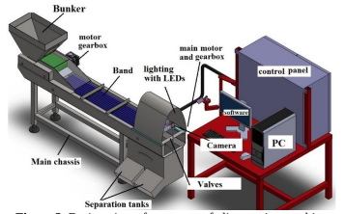

Figure : Olive Grading Machine Based on Machine Vision.

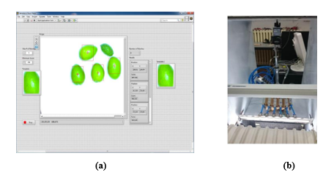
Figures : (a) Shows the machine’s interface (b) shows the high-speed cameras.

SIMULATION ON ANSYS
To evaluate this design of machine it has been simulated and analyzed on different software named as Solid works and Ansys. Different set of analysis and constrained has been performed on machine.

ANSYS SIMULATIONS:

Static structural Analysis of Grading Machine:
Roller drum tis subjected to different simulations and the result shows that design of base of grading machine so strong and robust [6]. The Mild steel has Young Modulus of 2.10 x 10^9 pascal, which is used in manufacturing of needle. The poison ratio is 0.40 and mesh size is 20 mm .Following are the analysis run on this mechanism to test its robustness.

ANSYS software is used to perform analysis on different parts of grading machine. Force being applied on the bottom plate of the machine, pressure being applied on the rolling drums after olives are placed for grading and fixed supports of the machine, the figures are as below

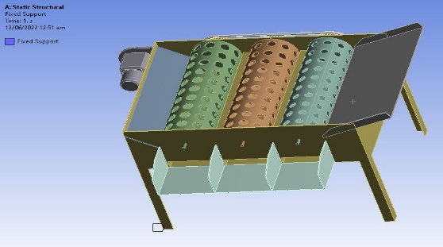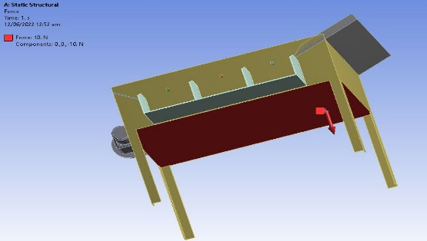
Fixed Support Force on the bottom plate

Simulation by load of 50N:

1) Directional and total deformation on x-axis:
A deformation option that displays all our model's deformation results in three coordinates (X, Y, and Z). We can examine the deformation result of your physical model in this direction by entering a coordinate (X, Y, or Z) in directional deformation.

The directional deformation in x axis is applied on the roller drums. 50N load was applied. The results shows that the stress is high, but it doesn’t exceed certain limit. The pictorial representation of the result is shown below:

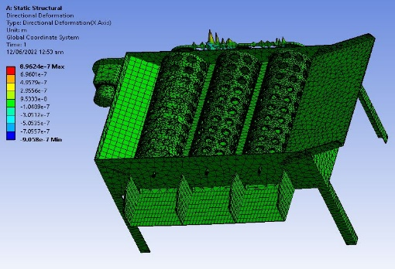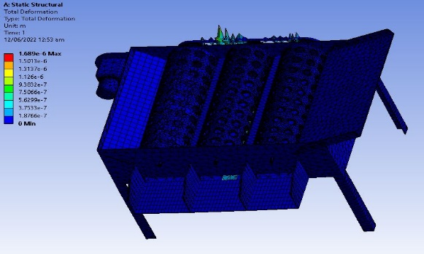
(1) (2)
1) Directional Deformation in X axis – 50N
2) Total Deformation – 50N

Von Mises Stress and elastic strain:
The drum is subjected to elastic strain and von misses stress are analyzed. 50N loads were applied to the drum. The results prove that drum is within limit and there are no chances that it will fracture. The following pictures shows the result carried out:
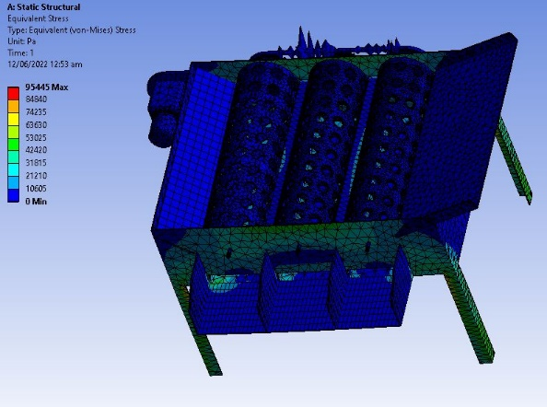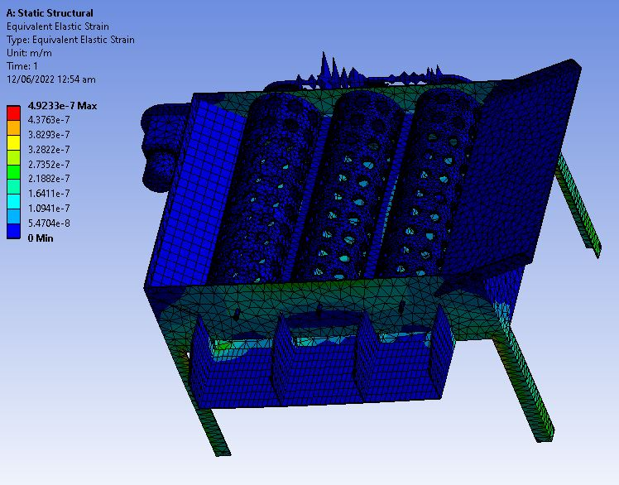
Analysis of Von-Mises Stress 50N Analysis of Elastic Strain – 50N

Roller Drum Carriers of Olives:
Roller drums are used for converting rotary motion to linear motion of fruit from the delivery plate. The coupler link was subjected to different simulations. The material for coupler is stainless steel and with Young Modulus of 2.10x10^7 pa. The mesh size is 20mm and poison ratio is 0.40. Following are analysis run on roller drums and complete structure of grading machine shows its robustness.

Output of Machine:
The olive pitting and grading machine is simulated in SOLID WORKS for motion analysis. The analysis shows that it is capable of grade 3 lines in 40 sec. We can conclude that machine is capable of grade 40-50kg of olives under certain conditions after analyzing the result.

FRUITS:
We will be discussing 2 types of olive crops in this study: “Ascolana and Arbequina”. An approx. of 100 olives were used in our study. We collected the olive to be tested from the farms in Barani Agriculture Research Institute, Chakwal. Then the measurements were taken of the selected olives.

GRADING-MACHINE:
Following figures shows us the different parts being used in the grading machine, schematic diagrams help us to understand the parts of the grading machine. The parameters depicted on the diagram are essentially those that will be determined for olives because of this investigation, to alter the grading machine to perform efficiently with this fruit [8].
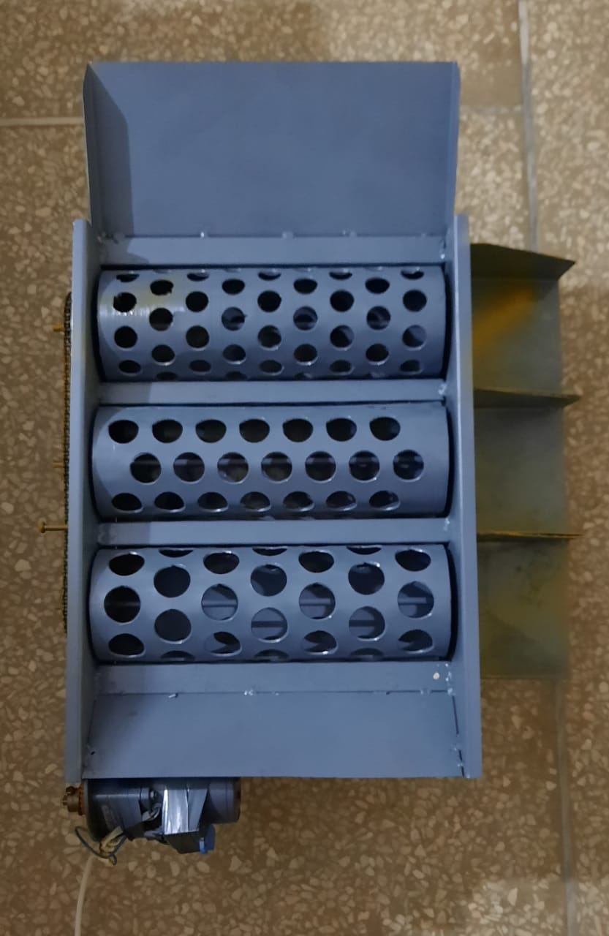
Top view of assembled machine

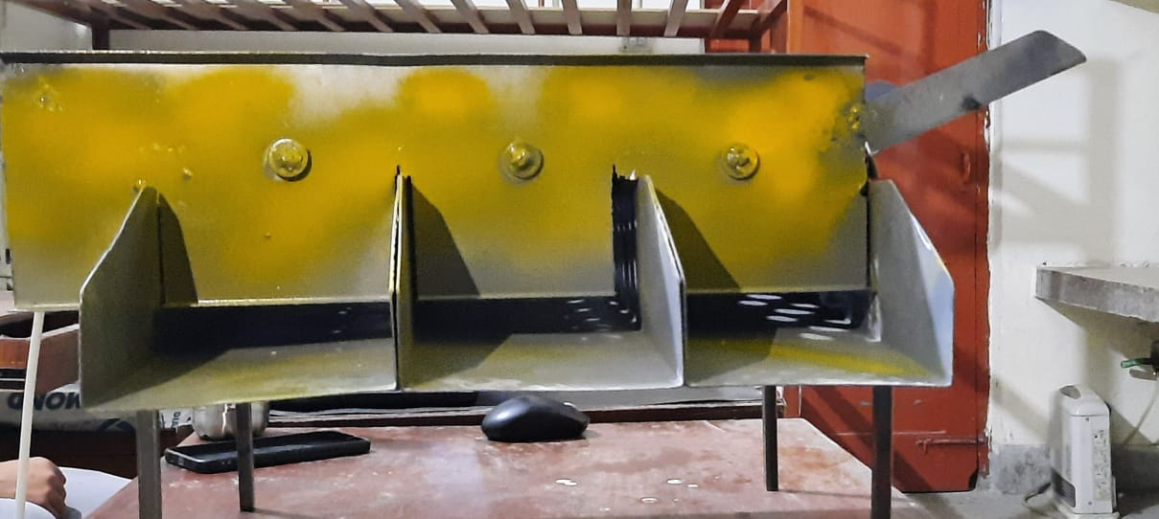
Side view of assembled machine

Designed Grading:

1) The Revolving Drums
Three revolving drums are made up of volcanized steel with following parameters: Diameter 92mm, length 305 mm, spacing 6mm, thickness 4mm. The three grading-drums have holes of diameters are 20-, 25- and 30-mm number of holes are 156, 137 and 124.
Iron metal-sheet of 330mm length, 457 mm width and 1.5 mm (14 gauge) of thickness was assembled above grading-drums spacing and bolted on two sides of fruit boxes.

2) Fruit output unit
The output unit is made up of volcanized steel with length of 457mm and width of 127mm. Three fruit cutoffs were inserted into the three grading drums and fixed to the left side of the frame. The fruits slide down the concave surface of the output unit and fall into funnels. The curved section prevents fruits from being jammed. The inclined angle of output unit calculated is 12 degrees.

Motor and Transmission System:
The grading system consists of 0.04 HP motor installed and chains are given below:

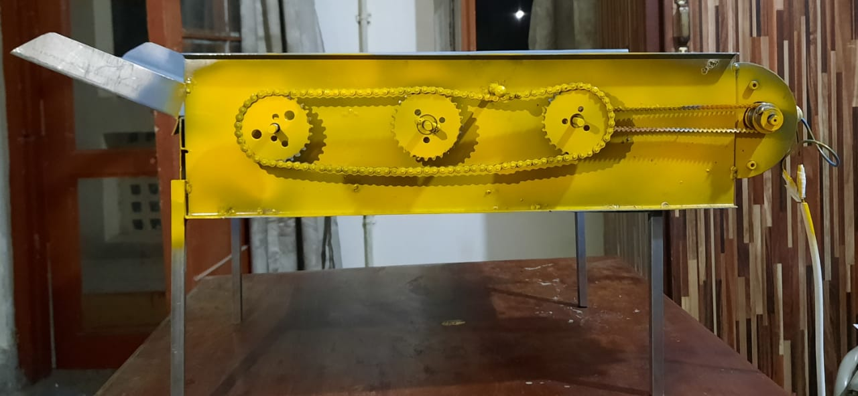
Chains side view of assembled machine

[1]

1 Olive hopper:

The top dimensions are of 350 x 330 mm and bottom dimensions of 350 x 80 mm. The frictional angle made with the hopper and 1st drum is 30 degrees.

2 Grading Drums:

The fruits are graded into three sizes using revolving drums. The diameter of the holes of the drum must be greater than the olives.
The fruit > 30 mm exit from the end of the machine. As there are 3 grading drums for 3 different types of olives. Rotating/Grading drums and holes in it of varying diameter is 20mm. Length to accommodate 305 cm.
The tangential angle of the drums in the fruit output direction must be more than 17 degree rolling angle between the olive fruits and the volcanized steel of grading machine. The tangential angle of the drums at the direction of drum motion is 7 degrees.

3 Olive output unit:
The tangential angle of the drums of rolling angles between the olives and volcanized steel surface must be kept greater than 17 degrees.

4 INSTRUMENTS INVOLVED IN THE PROCESS

Vernier Caliper

By the help of the Vernier Caliper with accuracy of 0.01mm we measured the different dimension of the olives.

Digital balance
The accuracy of the digital balance is 0.2g it is used to measure the mass of the olives.

Graduated cylinder

For calculation of the density and volume of the olives by immerging in water of 1000ml with an accuracy of 25ml.

4 Friction and Rolling Angle Measuring Device

An inclined plane was used to measure friction and rolling angles.

I) Friction angle measurement
The fruits are grouped together in a group on a horizontal surface, and the angle of inclination is progressively increased until the fruits begin to slide without rolling. Friction angles were calculated for each fruit group in a sample size of ten.

II) Rolling angle measurement

The fruits are placed one by one on flat plate, and the angle of elevation is progressively raised until the olives start rolling. Two rolling angles are calculated for each olive in an average sample (50).

Studied factors and measurements
The development grading-machine variables investigated were:

1 Grading speed:
Four different grading speeds 5, 8, 11 and 14 rpm (0.05, 0.08, 0.12 and 0.15 m/s).

Feeding rate:
Four different feed rates of 5, 10, 15 and 20 kg.

3 The Measurement were:
(1) Grading efficiency,
(2) Fruit damage
(3) Grading productivity.

Equations and Calculations

5.6.1 Sphericity Ratio
Sphericity ratio = fruit height (H) / fruit diameter (D) [10]
For olives: S.R = height / diameter
Table 1: Sphericity Ratio
Height (mm) | Diameter (mm) | Sphericity ratio
18.5 | 17.5 | 1.05
19.5 | 21.5 | 0.90
22.5 | 26.5 | 0.84

5.6.2 Projected Area
Projected area = 4/π (D * H)
Table 2: Projected Area
Height (mm) | Diameter (mm) | Projected area (mm²)
18.5 | 17.5 | 412.21
19.5 | 21.5 | 533.08
22.5 | 26.5 | 759.16

3 Real Density
Real density = Mass / Volume; Volume = 4/3 (3.14)(r³)

Table 3: Real Density
No. | Mass (kg) | Volume (mm³) | Real Density (kg/mm³)
1 | 5 | 2758.33 | 0.0022
1 | 5 | 3882.42 | 0.0013
1 | 5 | 5694.12 | 0.0009
2 | 10 | 2758.33 | 0.0036
2 | 10 | 3882.42 | 0.0025
2 | 10 | 5694.12 | 0.0018
3 | 15 | 2758.33 | 0.0054
3 | 15 | 3882.42 | 0.0038
3 | 15 | 5694.12 | 0.0026

4 Grading Productivity

According to; [11]

P = 3600 * M
T

P = Grading Productivity (kg/h)
M = Mass in sample (kg)
T = Time in seconds (s)

Table 4: Grading Productivity
Mass in sample (kg) | Time in seconds (s) | Grading Productivity (kg/h)
5 | 120 | 150
10 | 180 | 200
15 | 300 | 180

5 Grading Efficiency

According to [14], the grading efficiency of each outlet was computed as follows.

μ 1 = M₀₁1/Mi1
μ 2 = M₀₂1/Mi1
μ 3 = M₀₃1/Mi1
μ 4 = M₀₄1/Mi1

Where:
u1, μ2, μ3 and μ4: Grading efficiency of fruits for each outlet in the machine, (%).

Mi1, Mi2, Mi3 and Mi4: Mass of each class inside olive hopper, (kg).

M₀₁, M₀₂, M₀₃ and M₀₄: Mass of olives for each outlet in the machine, (kg)

6 Total Grading Efficiency:

‘T’ The total grading efficiency can be calculated by the following equation:

μ = (μ1+ μ2+ μ3+ μ4) / 4

7 Mechanical damage

Percentage of the mechanical damage was calculated by the following
formula:
D.F = Nd / Nt x 100

Where:

Nd0= No. of damaged olives
Nt0= Total olives

Table 5: Mechanical Damage
damaged olives | Total olives | D.F
25 | 100 | 25
28 | 80 | 35
35 | 75 | 46.67

7 Results and Discussions

1. Physical properties of olive fruits:

Dimensions, sphericity, mass, volume, actual density, and projected area of olive fruits are shown in Table 1. These statistics were collected on 100 fruit samples using the criteria established. [11]

2. Dimensions of fruit

If the sphericity is less than 0.9; if the sphericity is larger than 1.1, the fruit is classified as oblong. Roundness is assumed for the remaining fruits with intermediate index values [12]
The majority (85%) of olive in sample were round (sphericity 0.9 - 1.1), with oblong olive fruits accounting for 15% of the sample (sphericity 1.1 - 1.4).

Conclusion
Our grading machine established a mechanism for grading and pitting of olive fruits that has vast applications as table oil and used for the extraction of olive’s oil. In addition to project our senior degree we have designed a grading prototype machine for sorting of olives on their sizes.

The comparison of cost relative to other grading and pitting machines. The procedure we have carried out shows that olive pitting and grading machine holds importance both technically as well as from engineering point of view.

The importance of this machine is obvious from the fact provided that the production of such machines in Pakistan is non-existence due to lack of self-awareness and academic background.

For pitting of olives, the slider cranks and Geneva mechanism is used but there are high chances of wear and tear of these components so there are utmost requirements of some modifications in this design. Also, in grading machine of olives there are also some errors carried out in making the holes of drum roller for sorting of olives. Some holes are big enough that olives pass through it without going through grading process.

The results we have carried out on this machine are given below:
The maximum fruit damage during pitting and grading process was 6.3 to 6.6%. This was obtained with the grading speed of 8.2rpm (0.08 m/s) and feeding rate of 19kg. With the grading speed of 11.1 rpm the minimum damage obtained was 3.2 to 3.4 % with the fruit size of 20mm and feeding rate of 6kg. The maximum range of grading machine productivity for olives of 112-835 was obtained with grading speed ranging from 6-15 rpm (0.06-0.16 m/s) and feeding rate was 19kg.

The minimum range of grading machine productivity for olives fruits of 100-685 was obtained with grading speed of 5-14 rpm (0.06-0.15 m/s) and feeding rate of 5kg. The effective cost of our grading machine was from 38-40k.

The advancement in the machine can made by converting it to fully automatic from semi-automatic machine. In this way labor effort and cost is reduced and high efficiency can be obtained. This advancement in the machine can serve as economic booster in country as there is high demand of olive’s oil.

Acknowledgment
We would like to thank our Supervisor, Dr. Hamid Jabbar and Co-Supervisor Dr. Umar Shahbaz for his insight, guidance and help in accomplishing this task. It has been a privilege to work under his supervision. We are grateful for his motivation and efforts that he gave us.

Furthermore, we feel honored to have been taught by an excellent faculty and to have been graced with peers and friends without whom my pursuit of education would have been less gratifying.

These acknowledgments would not be complete without expressing our appreciations for my family whose continuous and firm support has enabled us to focus on our work without distraction.
We pray that Allah Almighty bestow upon them his blessings and bounties and continue to guide us in our future endeavors.

References

[1] F. J. Cimperman, "Machine for pitting and stuffing olives".Google patents.
[2] T. Britannica, "Encyclopedia Britannia," Editors of Encyclopedia, 1 May 2019. [Online]. Available: https://www.britannica.com/plant/olive-plant. [Accessed 6 June 2022].

[3] Barani Chakwal Institute Management, "Barani Agriculture Reseacrh Institute," 5 June 2013. [Online]. Available: barichakwal.punjab.gov.pk/background. [Accessed 4 June 2022].
[4] F. P. M. TYQH-06, "THOYU," 5 MAY 2015. [Online]. Available: thoyu.com/ty-qh06- fruit-pitting-machine.html. [Accessed 1 DEC 2021].

[5] M. M. C. Ltd, "Miracle Machinery," 2 Sep 2016. [Online]. Available: http://www.mrcfoodmachine.com/fruits-processing-machinery/olive-processingmachinery/automatic-olives-pitting-machine.html.

[6] E. G. M. G. H. J. U. S. Ahmed Faizan, "IEEE," June 2021. [Online]. Available:
https://ieeexplore.ieee.org/abstract/document/9651337. [Accessed Jan 2021].

[7] PARC, "Pakistan Agriculture and Research council," 11 August 2014. [Online]. Available: http://www.parc.gov.pk/index.php/en/olive-history-of-olive-in-pakistan. [Accessed 6 June 2022].

[8] A. Lucas, "Deep learning in olive pitting machines by computer vision," 2018. [Online]. Available: sciencedirect.com/science/article/abs/pii/S0168169919310464. [Accessed 2022].

[9] T. E. o. E. Britannica, "Britannica," Britannica, [Online]. Available: https://www.britannica.com/technology/slider-crank-mechanism

[10] IOSR-JAVS, "Journal of Agriculture and Veterinary Science," Agriculture and Veterinary Science, vol. 9, no. 11, pp. 2319-2380, 2016.

[11] TRENT BULLOCK, "WHAT DOES "FOOD GRADE" MEAN?" Dec 2017. [Online]. Available: https://www.csidesigns.com/blog/articles/what-is-food-gra
de.

[12] El-Raie, A.E.; M.M. Attaullah; K. S. Khalil, "Factors affecting the design of a grading machine for lemon fruits,
Misr J. Ag. Eng., vol. 2, p. 29, 2012.

[13] Buyanov, A. I.; Voronyuk, B. A., Physical and mechanical properties of plants, fertilizers and Soils, New Delhi, Bombay, Calcutta: Amerind Pub. Co., PVT, LTD, 1985.

